How to disable Green Power function?

First, Turn off UPS, disconnect any input and output.

Second, Loosen the screws and take off the UPS cover.

Third, Disconnect the battery from PCB, then press the switch button On/Off to let out the remanent electric energy existing on PCB

Fourth, Check the PCB part number which marked on the edge of PCB, confirm it 098-18377-XX or 098-18224-XX (XX means 01 02 ……). Because the modification method below is only suitable for the certain PCB which part number is 098-18377-XX or 098-18224-XX.

Fifth, Check the PCB and find 3 positions ---- R1A, R2A, D1A, just as below:

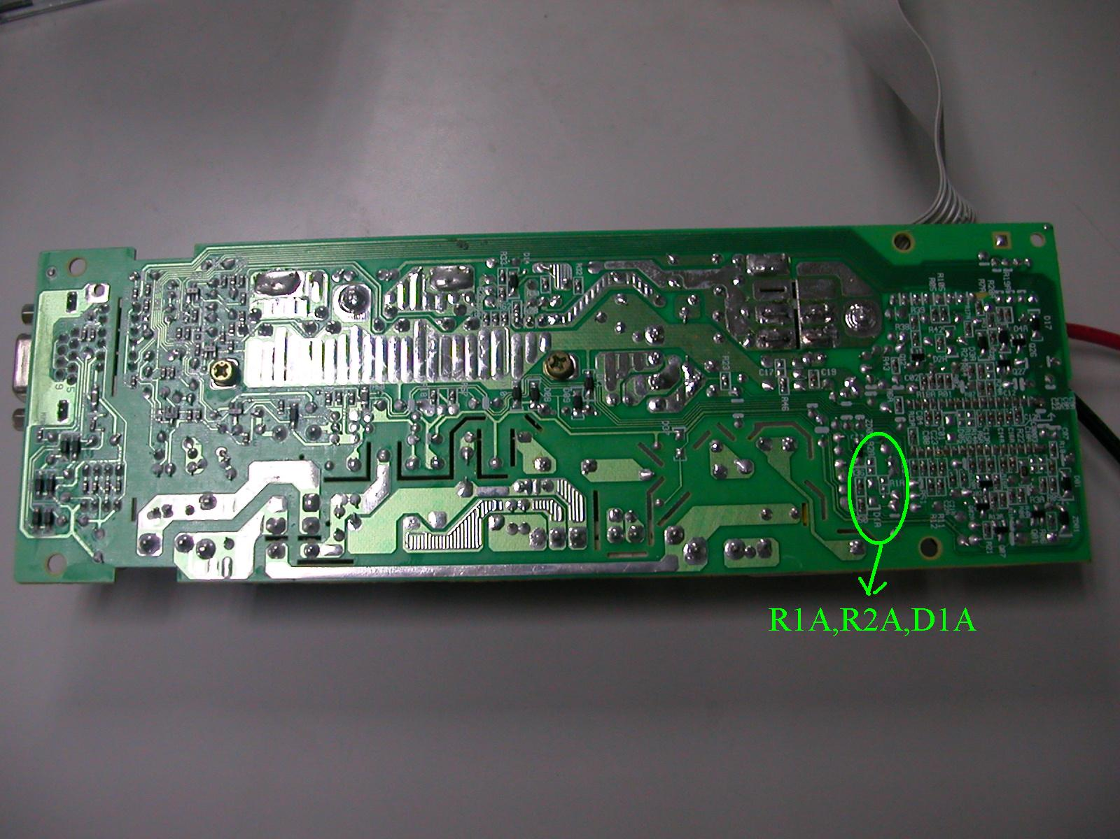
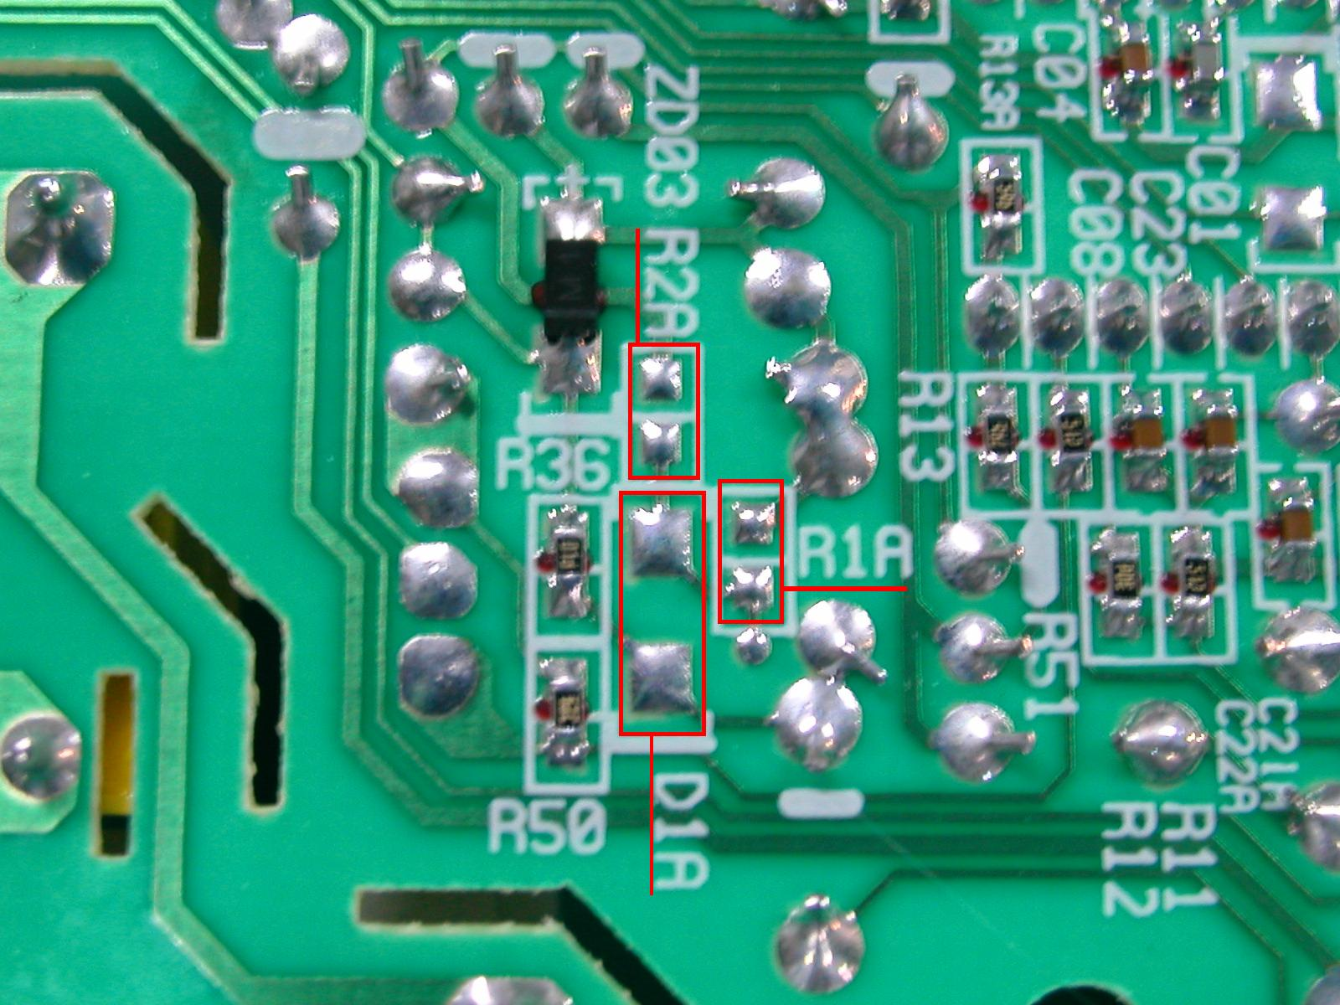

Sixth, Add the 3 components on the 3 positions:
R2A add RES CHIP TF 1/10W 30K F (0603) (AI)
R1A add RES CHIP TF 1/10W 10K F (0603) (AI)
D1A add DIODE 1N4148W (SMD) 0.15A /75V (AI)
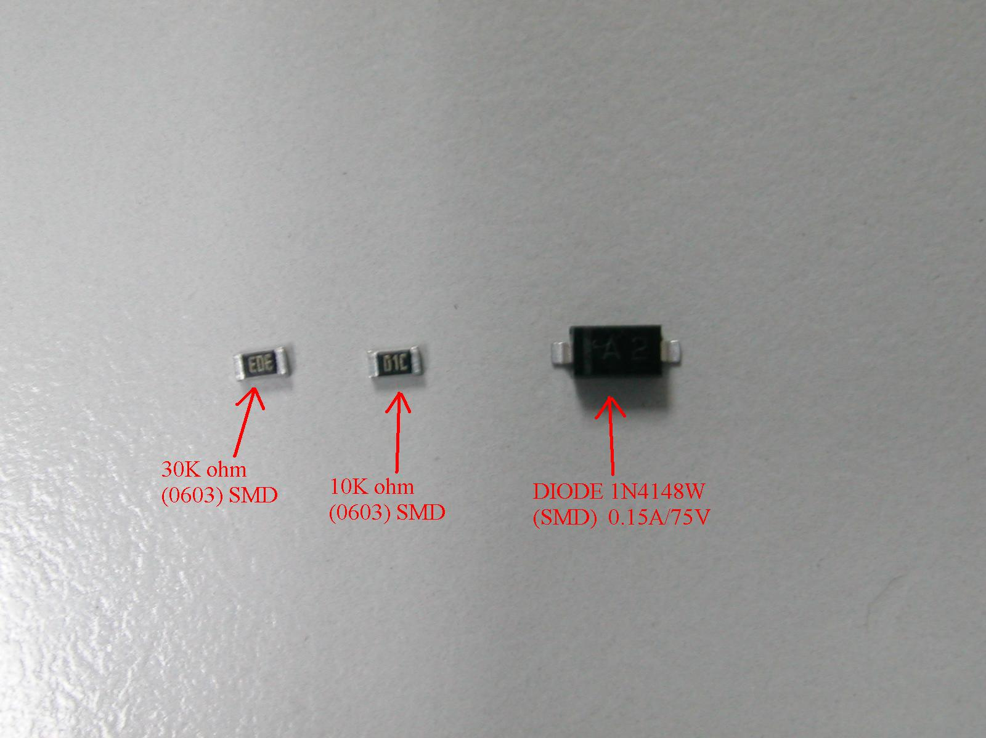

Seventh, Re-assemble PCB to unit

